Congratulations on finishing all five modules of this course. This week, you'll work on your final assignment which will be graded by your peers.

Although this course introduced you to multiple data science tools, this final project will use Jupyter Notebooks, as they are the easiest to share publicly.

**Leveraging Jupyter Notebooks on IBM Watson Studio, create your own Jupyter Notebook (in English) and share it via a public link.**

**Review criterialess**

**Assignment Topic:**

Create a Jupyter Notebook using IBM Watson Studio. You can choose any language you want (Python, R, or Scala). You will need to include a combination of markdown and code cells. You will likely need to use the [Markdown cheatsheet](https://github.com/adam-p/markdown-here/wiki/Markdown-Cheatsheet) to help you determine the appropriate syntax to style your markdown.

**Guidelines for the submission:**

* Create your Jupyter Notebook on [IBM Watson Studio](http://cocl.us/DSX_DS0105_Coursera)
* Include at least 6 cells:
* **Cell 1 (rendered as Markdown)**: The title should be "My Jupyter Notebook on IBM Data Science Experience", in H1 header styling. The title does not need to be centered.
* **Cell 2 (rendered as Markdown)**: Your name, in bold characters. In the line below your name, write your current or desired occupation in regular font.
* **Cell 3 (rendered as Markdown)**: In italic formatting, write one or two sentences about why you are interested in data science. For example, you can start your first sentence with "I am interested in data science because ...".
* **Cell 4 (rendered as Markdown):** In H3 header styling, explain in a short sentence what your code is supposed to do in Cell 5.
* **Cell 5 (code cell):** Your code, as described in Cell 4. It must be executed and must display an output. Try to keep the code simple (it can even be "1 + 1").
* **Cell 6 (rendered as Markdown):** Using Markdown or HTML, this cell must include at least 3 of the following: horizontal rule, bulleted list, numbered list, tables, hyperlinks, images, code/syntax highlighting, blocked quotes, strikethrough.

**Submit:**

1. The URL of your publicly shared notebook on IBM Watson Studio.

The **main grading criteria** will be:

* Is the notebook publicly viewable?
* Are there, or does there appear to be, at least 5 Markdown cells and 1 code cell?
* Are the criteria for each cell fulfilled, as described in the "Guidelines for Submission"?

You **will not be judged** on:

* Your English language, including spelling or grammatical mistakes.
* The content of any text or image(s) or where a link is hyperlinked to.

**Step-By-Step Assignment Instructionsless**

**How to generate a publicly viewable share link for your Jupyter notebook:**

1. With a Jupyter notebook open on Watson Studio, first ensure that you have saved, by going to "File" then "Save Version".
2. Click on the Share button, as shown below:

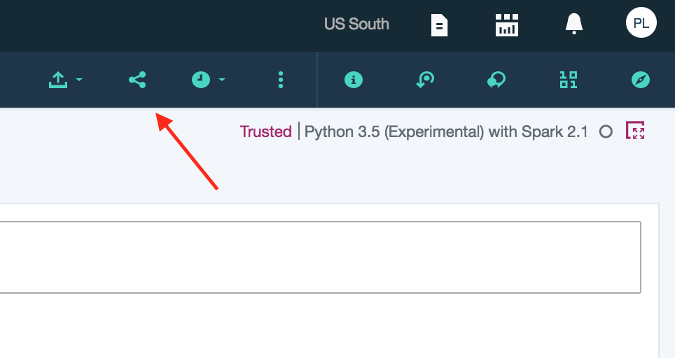

2. Choose the following settings to retrieve your public link to your Jupyter Notebook:

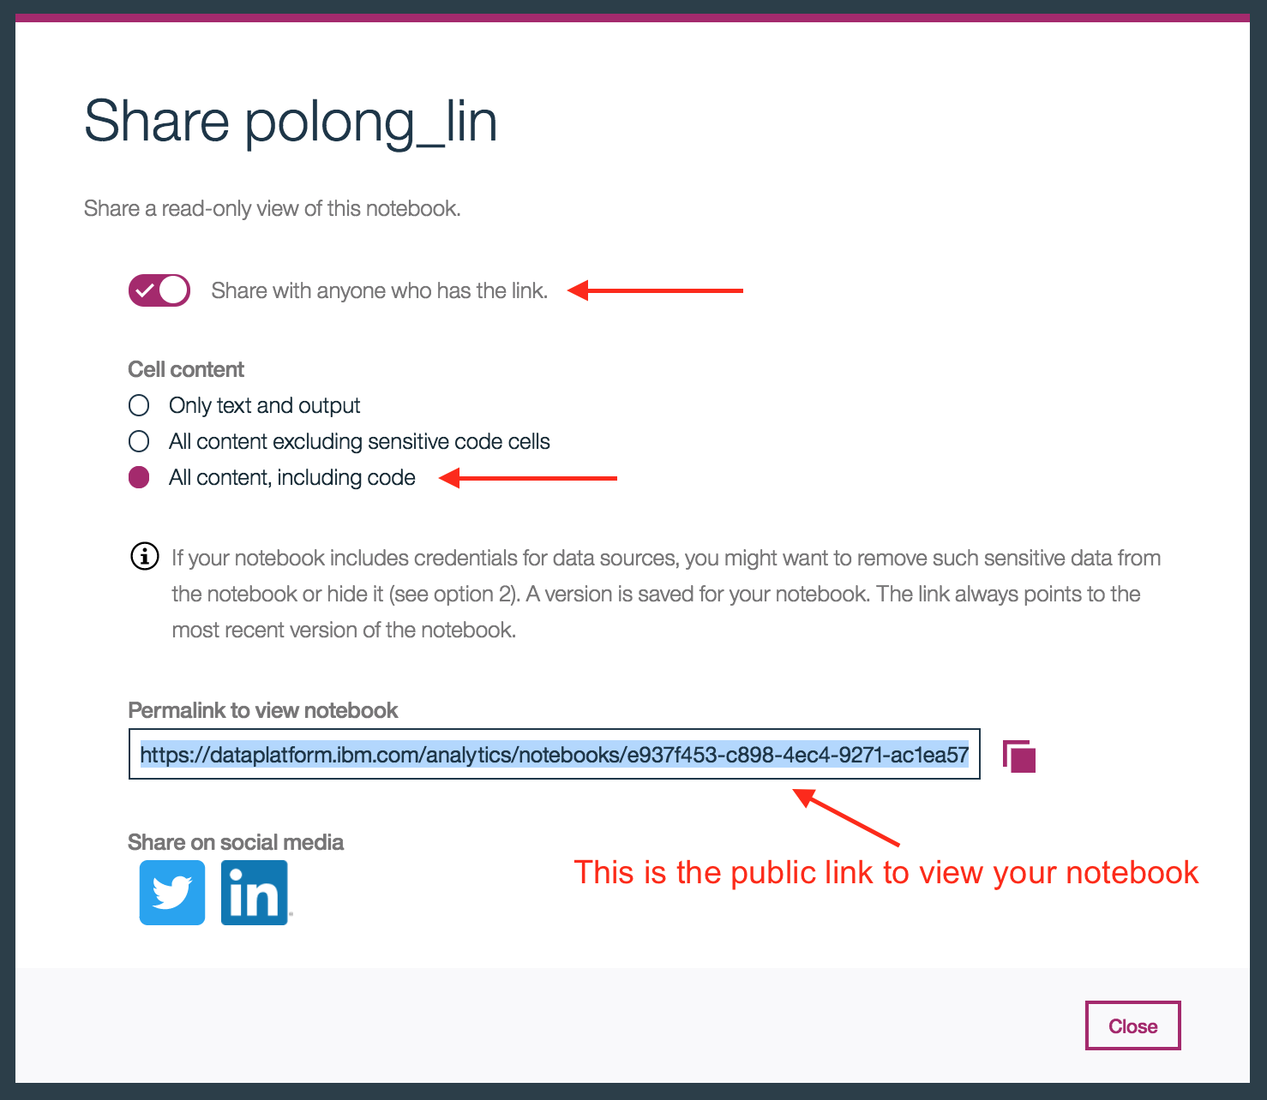

3. To ensure that everyone else can view the notebook, you can visit the link yourself from an incognito or private window. Alternatively, you can log out of your Watson Studio account and try to visit the link and ensure you can see the contents.

**Example Submissionsless**

Here is an example of a final submission:

